**Part 1:**

**Title:** Universal Location and weather finder.

**Description:** The app combines two web services (openweather map api, google maps api), to render a completely dynamic and unique mashup. The user can just enter the name of any city in the world and the app will find the city and when the user clicks on the marker it pops up a info windo with the current weather information of the city.

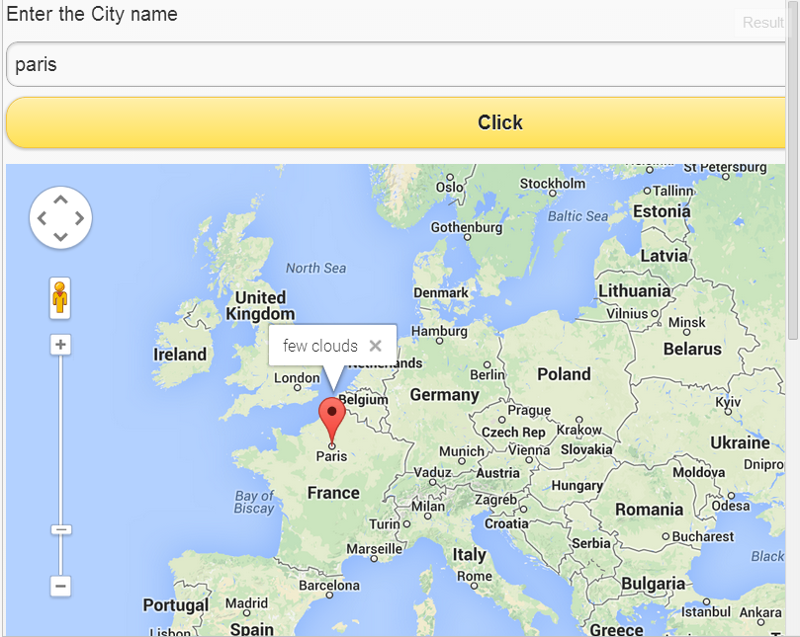

Jsfiddle link: http://jsfiddle.net/arf62/L5xak/10/

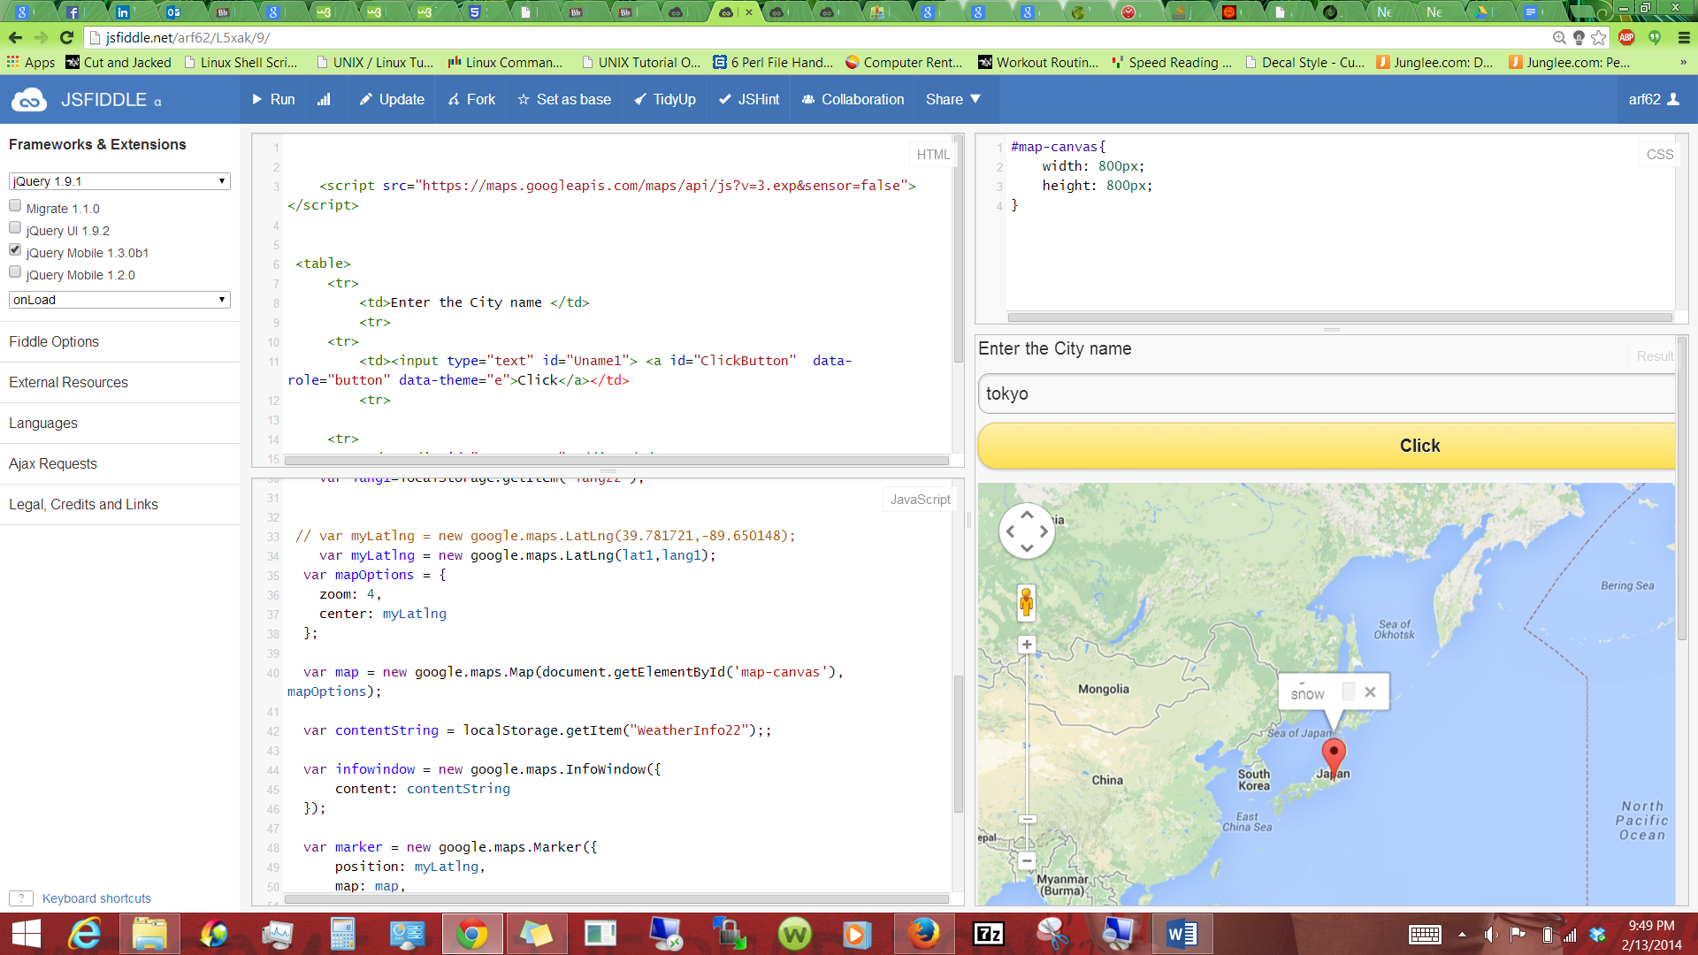

How it works:

**Scaning the user input.**

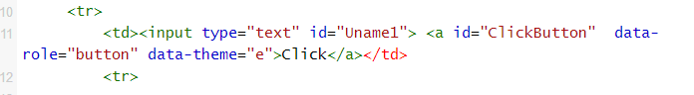

**Using the user input to fetch json data and then parse the jason data.**

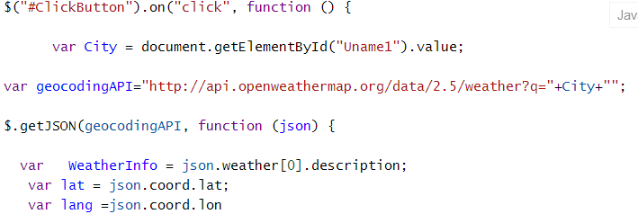

**Saving the json data in the HTML 5 local storage.**

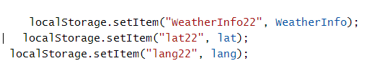

**Retriving the local storage data and passing it to google maps api to render the map.**

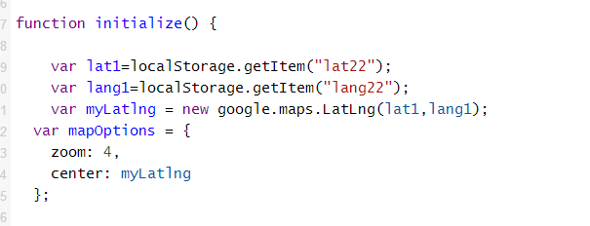

**Part 2:**

The following screen shot shows the Vm after installing the Vmplayer and setting up the image.

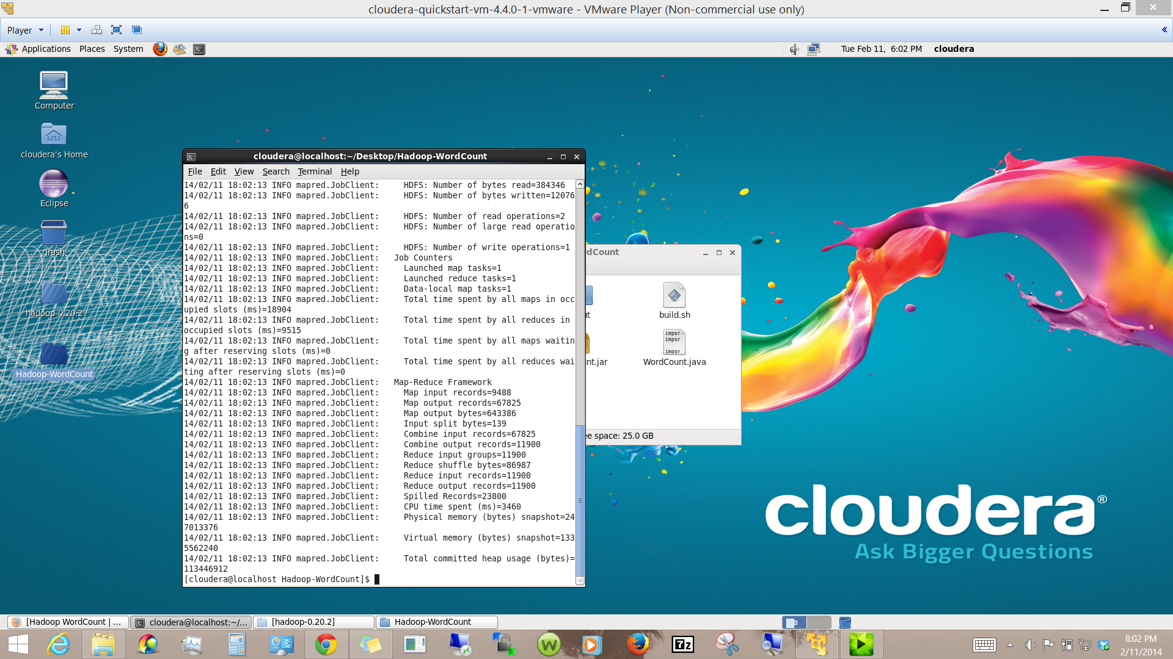

The following screen shot shows the cloudera manager.

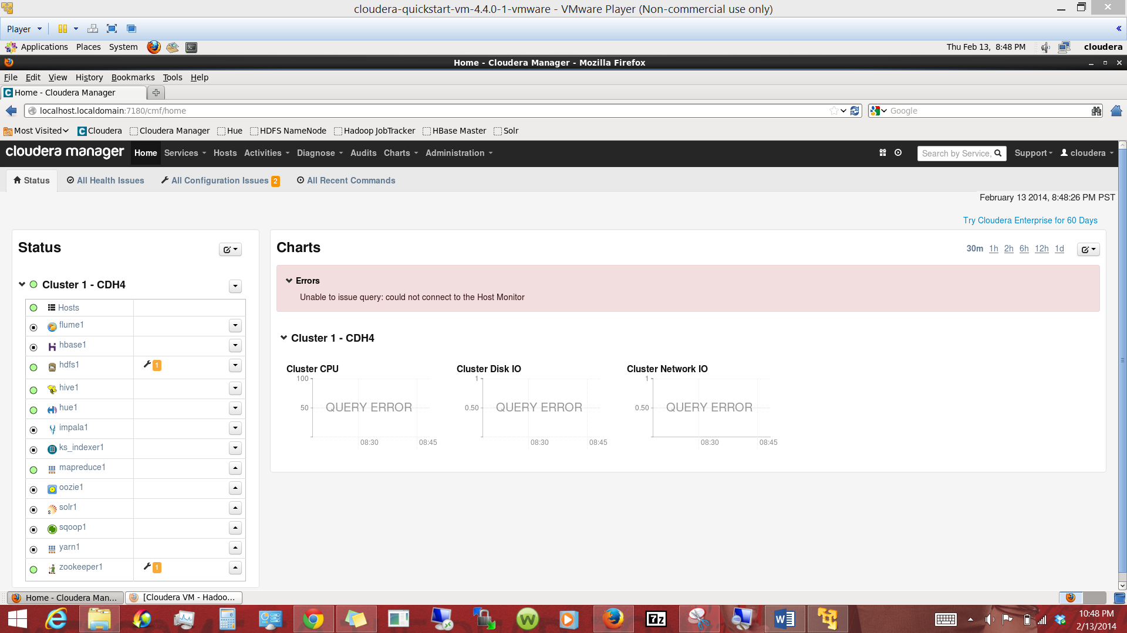

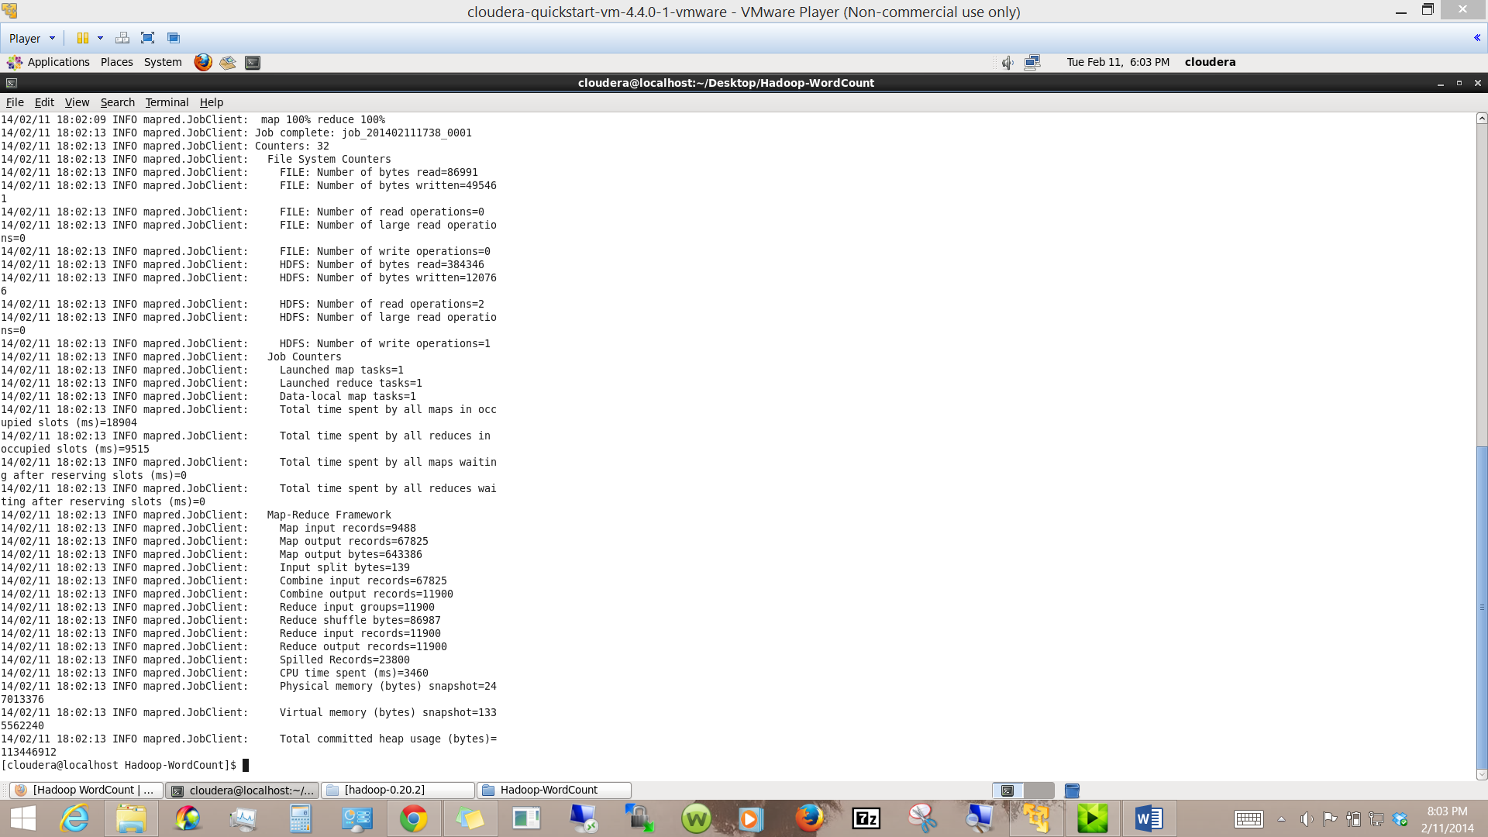

After running the map reduce.

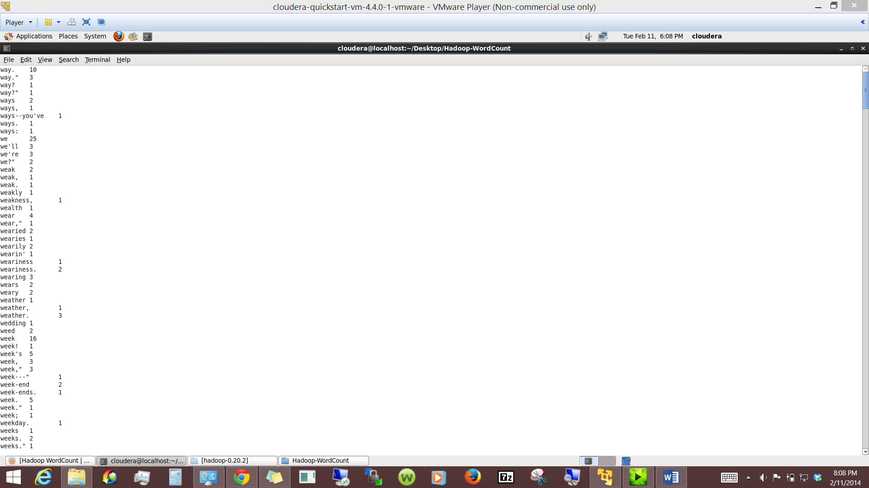

Installing the Mahout.

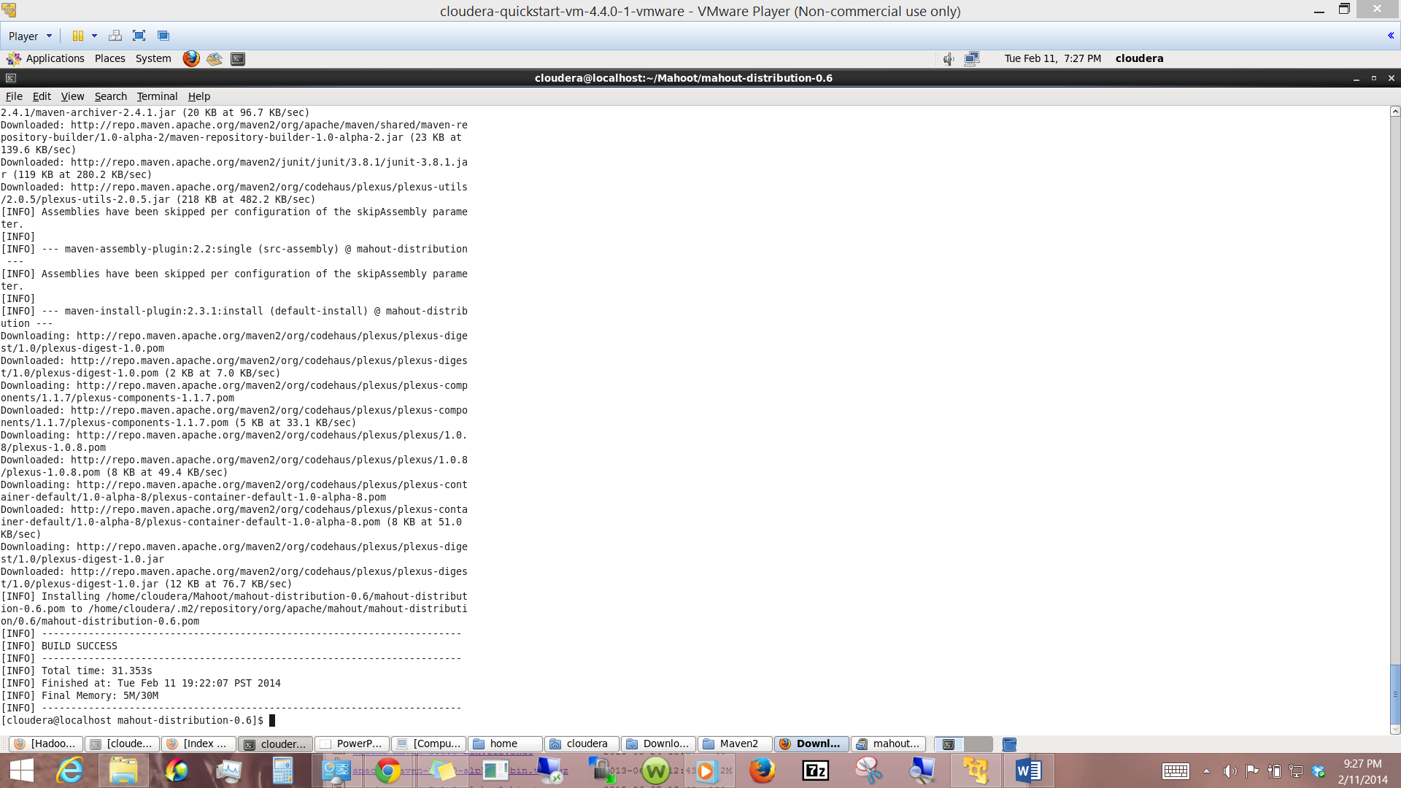

Naivebayes running result as Confusion Matrix:

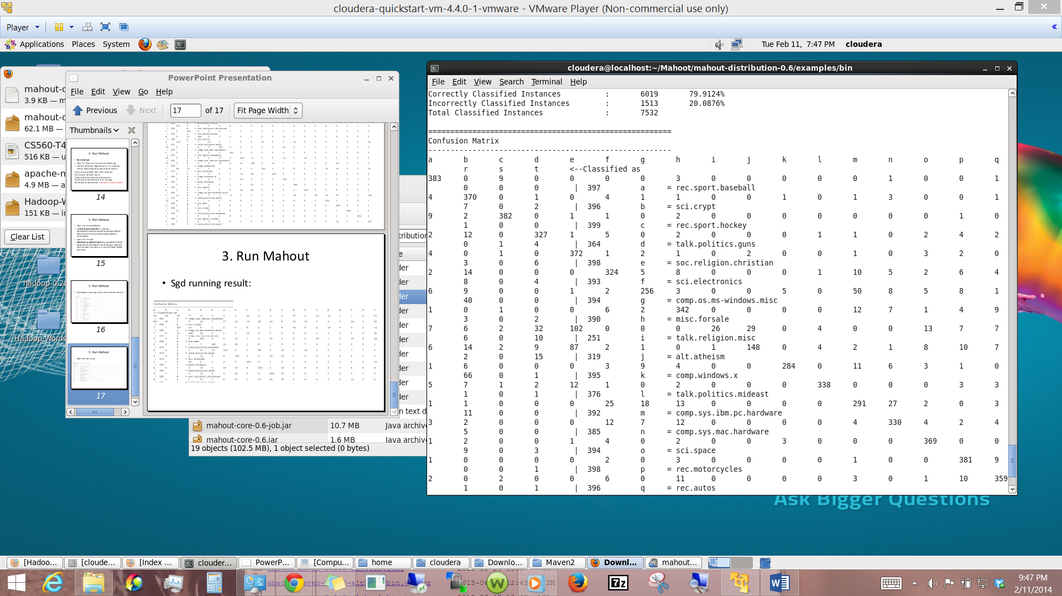

Sgd running result:

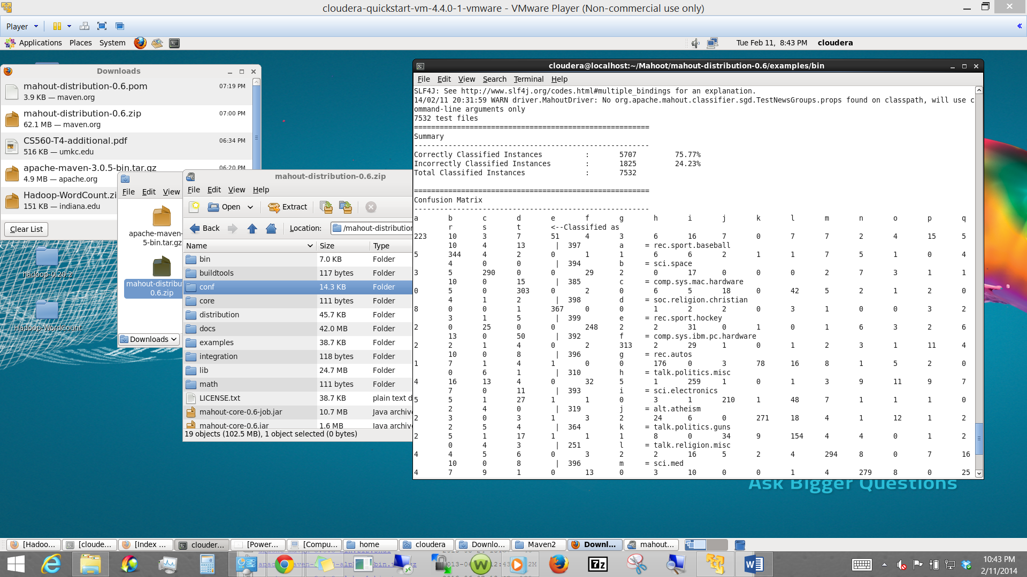

Bibliography:

Google maps api,

Material provided in class.